JPR Assignment 6
1. Difference between ODBC and JDBC.
Ans.
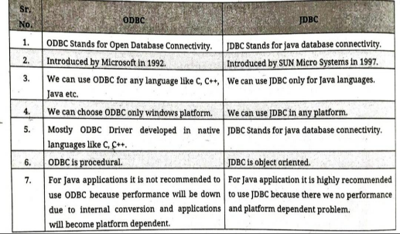

2. Explain 4 types of JDBC Drivers.
Ans.
JDBC (Java Database Connectivity) drivers are used to connect Java applications with databases.
There are four types of JDBC drivers, each working differently to establish the connection between a Java program and a database.
1. Type 1: JDBC-ODBC Bridge Driver
• Uses the ODBC (Open Database Connectivity) driver to connect to the database.
• Translates JDBC method calls into ODBC calls.
• Advantage: Easy to use for testing.
• Disadvantage: Requires ODBC driver to be installed. Not suitable for production.

2. Type 2: Native-API Driver
• Converts JDBC calls into native database API calls using database-specific libraries.
• Advantage: Better performance than Type 1.
• Disadvantage: Platform dependent. Requires native DB libraries on the client machine.

3. Type 3: Network Protocol Driver
• Sends JDBC calls to a middleware server which then connects to the database.
• The middleware server handles the database communication.
• Advantage: No client-side database library needed. Good for internet-based applications.
• Disadvantage: Requires middleware server setup.

4. Type 4: Thin Driver (Pure Java Driver)
• Directly converts JDBC calls to the database-specific protocol.
• Written entirely in Java.
• Advantage: Platform independent, best performance, widely used.
• Disadvantage: One driver per database (e.g., MySQL, Oracle, etc.).

3. Write any four methods of Statement.
Ans.
1. executeQuery(String sql)
2. executeUpdate(String sql)
3. execute(String sql)
4. close()

4. List methods of ResultSet Interface.
Ans.
1. boolean next()
2. boolean previous()
3. boolean first()
4. Boolean last()

